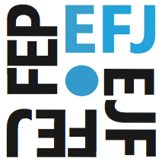
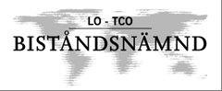
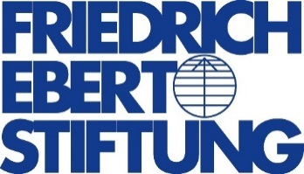
Skopje Conclusions

Campaigning for Journalists Rights in Eastern Europe:
Union Recruitment, Legal protection and Social Rights

6-7 October 2014 Skopje, MACEDONIA

The meeting agreed the following Actions

Session One: Status of Journalism in Macedonia
- endorsed the call for the immediate release of Tomislav Kezarovski
- agreed to pursue the Kezarovski campaign in the run up to his appeal court appearance on 24 October
- gave further support to Zoran Bojinovski, the Macedonian investigative journalist residing in Serbia facing an attempt to extradite him to Macedonia to face espionage charges
- supported the demands drafted by the Trade Union of Macedonian Journalists and Media Workers (SSNM) and the Association of Journalists of Macedonia (AJM) for urgent reform of Macedonian media including,
  - the guaranteed independence of public broadcaster and audiovisual regulator;
  - the end to corruption of media through government advertising and public campaign funds;
  - respect of freedom of association, basic labour rights and an end to interference in the work of the association and the trade union;

Session Two: Unions Organising the Fight Against Insecure Contracts, Poor Salaries and Exploitative Working Conditions

- Condemned employers who target union members for dismissal
- Supported the efforts to develop new recruitment strategies particularly in the online media
- Congratulated in particular the success of the Journalists Union of Turkey (TGS) public communication and recruitment campaign that has seen three new collective agreements in the past six months
- Supported strengthening the union organizing training programme

Session 3. Digital Tools for Organising, Recruitment and Safety
- Agreed the development of digital membership databases for unions
- IFJ to develop the database structure to be rolled out to unions in 2015

Session 4. National Campaigning Case Studies
- Endorsed the efforts of all journalists unions to campaign for their members’ rights
- Congratulated NUJU and IMTUU for their response to the Ukraine crisis and their programme of support and safety, and trauma, for journalists reporting the conflict
- Supported the co-operation between the Russian and Ukraine journalist unions in protecting journalists reporting the conflict in Ukraine
- Agreed to campaign for the release of the journalists missing, believed detained in the East of Ukraine
- To increase support for national campaigns from IFJ/EFJ and regionally

Session 5: Legal instruments to protect Journalists.
- Condemned the employers who have targeted union leaders for dismissal including Tamara Chausidis, (SSNM), Mustafa Kuleli (TGS) and Marijana Camovic (MTUM)
- Called on IFJ / EFJ to support taking legal cases to the ILO for breach of right to association cases
- To develop best practice use of legal funds to defend journalists in labour cases and in training of journalists on their labour rights
- Agreed to conduct a survey into the extent of the targeting of union members by employers whether leaders or ordinary members, to use as a lobbying tool to raise awareness of the extent of the abuse at the EU.

